AI KAVACH
(AI Shield)
Real-Time Audio Deepfake and Voice-Cloning Financial Scam Detection for Indian Regional Languages

Capstone Project Report
AI / GPU-Intensive Internship Program
Developed on an NVIDIA H200 GPU Cluster via JupyterHub
Submitted by: INCHARA M
USN: 20241CAI0211
Submitted on: 10/7/2026
Motivated by SEBI and RBI advisories on voice-cloning investment fraud in India

1. Introduction
Voice-cloning technology has advanced to the point where a few seconds of recorded speech are enough to generate a convincing synthetic replica of a person's voice. In India, this capability has been increasingly weaponized in financial fraud: scammers impersonate relatives, bank officials, or investment advisors over phone calls to pressure victims into transferring money or revealing sensitive account details. Both the Securities and Exchange Board of India (SEBI) and the Reserve Bank of India (RBI) have issued public advisories warning citizens about voice-cloning-enabled investment fraud, highlighting the urgency of building practical, deployable countermeasures.
AI Kavach ("AI Shield") is a capstone project that addresses this problem directly. It is a real-time audio deepfake detection system designed to distinguish authentic human speech from AI-synthesized or cloned speech, with a specific focus on Indian regional languages — Hindi, Kannada, and Tamil. The project was developed end-to-end during a short-term AI/GPU-intensive internship, using an NVIDIA H200 GPU cluster accessed through JupyterHub.

1.1 Motivation
- Rising incidence of voice-cloning scams targeting bank customers and retail investors across India.
- Explicit regulatory concern: SEBI and RBI advisories calling out voice-based impersonation fraud.
- A visible gap in detection tools built specifically for Indian regional languages, which are underrepresented in existing deepfake-detection research.
- An opportunity to convert a short internship into a press-worthy, demonstrable product rather than a purely academic exercise.

1.2 Objectives
- Build a binary classifier that reliably distinguishes real human speech from synthetic/cloned speech.
- Support Hindi, Kannada, and Tamil in addition to English, reflecting the languages most exploited in reported scam calls.
- Package the model behind a real-time inference API suitable for integration into a call-monitoring or call-screening workflow.
- Present the system through a working demo that non-technical evaluators (faculty, judges, press) can understand at a glance.

2. NVIDIA H200 GPU: Infrastructure and Development Timeline
Every stage of AI Kavach — data preparation, model fine-tuning, and inference testing — was carried out on an NVIDIA H200 GPU, accessed through a JupyterHub notebook environment provided for the internship. This section explains why that specific hardware mattered, how it was actually used, and how the ten lab days of the internship mapped onto the project's build-out.

2.1 Why the H200 GPU
- Large HBM3e memory (141GB): comfortably holds the Wav2Vec2-XLSR-53 backbone, LoRA adapters, and full-size audio batches in memory together, instead of forcing small batches or gradient-accumulation workarounds.
- High memory bandwidth: speech transformers are attention-heavy; faster memory bandwidth directly shortens both training and inference time, which mattered on a fixed ten-day schedule.
- Headroom for iteration: with a short internship window, the ability to re-run training or preprocessing quickly after a bug fix — rather than waiting on a queue — was essential to actually finishing a working prototype.
- Shared-cluster access via JupyterHub: the H200 was made available as a notebook backend, so no local GPU or manual CUDA setup was needed — the environment was ready to use from day one.

2.2 How the H200 Was Used
- Data preparation (data_prep.py): loading and resampling Mozilla Common Voice audio and generating Coqui XTTS voice clones, both run as GPU-accelerated notebook cells.
- Model fine-tuning (train_lora.py): LoRA/PEFT adapters injected into the frozen Wav2Vec2-XLSR-53 backbone were trained on the H200, with GPU memory and utilization monitored throughout each run.
- Inference testing (infer.py, api.py): the trained adapters and classification head were reloaded onto the same GPU environment to validate real-time inference latency before wiring the FastAPI backend to the demo frontends.
- Notebook-native workflow: because JupyterHub executes commands cell-by-cell, all shell operations used the '!' prefix and '%cd' magics rather than plain shell syntax — a small but important adjustment to the usual development workflow.

2.3 Ten Days in the Lab: How the Timeline Maps to the Project
The internship ran as a ten-day, GPU-intensive lab. Rather than treating data work, model work, and demo work as separate tracks, AI Kavach was deliberately structured so each lab day built directly on the previous one's output on the H200 cluster.
Day | Focus | Output
Day 1 | H200 / JupyterHub environment setup; installed transformers, PEFT, torchaudio | Working GPU notebook environment
Day 2 | Studied SEBI/RBI advisories and existing voice-cloning fraud patterns | Problem scope and target languages fixed
Day 3 | Sourced and explored Mozilla Common Voice (Hindi, Kannada, Tamil, English) | Real-speech dataset shortlisted
Day 4 | Generated synthetic voice clones using Coqui XTTS | Paired real vs. synthetic samples
Day 5 | Built and ran data_prep.py end-to-end on the H200 cluster | Verified, labelled training dataset
Day 6 | Studied Wav2Vec2-XLSR-53 architecture; designed LoRA/PEFT configuration | train_lora.py scaffold
Day 7 | Launched first LoRA fine-tuning runs on the H200; monitored loss curves | Initial training checkpoints
Day 8 | Iterated on hyperparameters and debugged convergence issues | Refined training configuration
Day 9 | Built infer.py and the five-stage FastAPI backend (api.py) with per-stage logging | Working inference pipeline
Day 10 | Built both HTML demo interfaces and ran integration tests end-to-end | Presentation-ready demo + report

This day-by-day structure is what let a ten-day internship produce a complete pipeline rather than an isolated model: each day's H200 output — the dataset, the checkpoint, the API, the demo — became the next day's starting point.

3. System Architecture
AI Kavach is organized as a clear five-stage pipeline sitting on top of a fine-tuned speech transformer, running end-to-end on the H200 GPU described in Section 2. The diagram below shows how a call or uploaded clip moves through the whole system, from the demo frontend to the model and back.
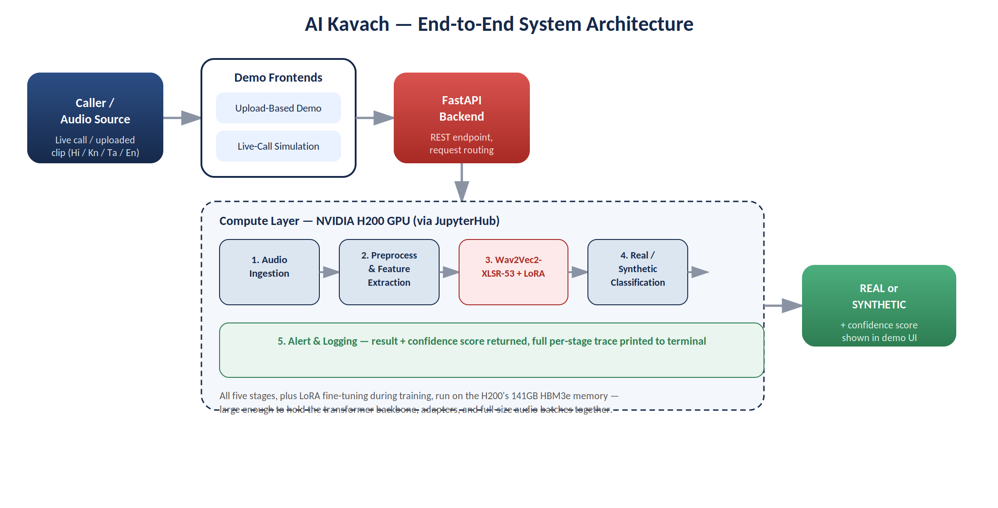
Figure 1: End-to-end system architecture, from caller to verdict
This section explains, in order: which model was chosen, why it was chosen over the alternatives, and exactly how it is used inside the pipeline — since these three questions are the ones most evaluators ask first.

3.1 Which Model: Wav2Vec2-XLSR-53
The core of AI Kavach is Wav2Vec2-XLSR-53. It is important to be precise about what this model is: it is an audio transformer, pretrained directly on raw speech waveforms — it is not a large language model (LLM) and does not process text. Architecturally it has two parts: a convolutional feature encoder that turns a raw waveform into a sequence of latent audio frames, followed by a 24-layer transformer encoder that applies self-attention over those frames to build contextual speech representations. "XLSR-53" refers to the fact that this backbone was pretrained via self-supervision on unlabelled speech from 53 languages at once, which is what gives it usable representations for Hindi, Kannada, and Tamil out of the box, rather than only English.

3.2 Why This Model (and not something else)
- Not an LLM: the task is acoustic — detecting synthesis artifacts in a waveform — which needs a model that consumes raw audio, not tokenized text. An LLM has no native way to see waveform-level detail like pitch jitter or vocoder artifacts.
- Multilingual by default: XLSR-53's 53-language pretraining removes the need to pretrain a backbone from scratch for Hindi, Kannada, and Tamil, which would be infeasible on a short internship timeline.
- Self-supervised pretraining already encodes phonetics: the backbone was trained to predict masked audio segments, which forces it to learn fine-grained phonetic and acoustic structure — precisely the kind of detail that differs between genuine human speech and vocoder-generated speech.
- Practical to fine-tune on available compute: full fine-tuning of a 24-layer transformer is expensive; parameter-efficient fine-tuning (LoRA) on top of this backbone made it feasible to get a working model on the H200 cluster within the internship window.
- Proven for anti-spoofing: Wav2Vec2-family backbones are widely used as front-ends in academic audio anti-spoofing and deepfake-detection systems, making this a well-supported choice rather than an untested one.

3.3 How the Model Is Used
The backbone itself is not retrained from scratch and its original weights are frozen. Instead, AI Kavach uses LoRA (Low-Rank Adaptation) through the PEFT library to attach small, trainable rank-decomposition matrices inside the transformer's attention layers. Only these adapter matrices, plus a newly-added classification head on top of the pooled output, are actually trained — the diagram below shows this split.
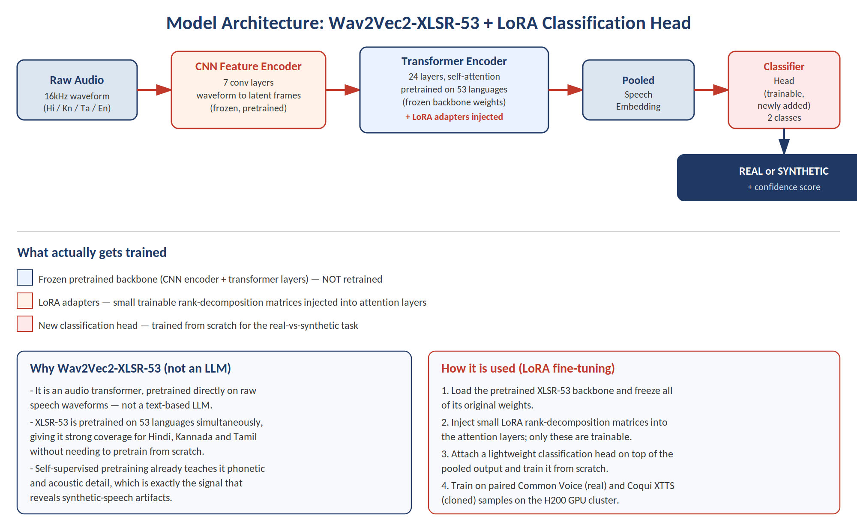
Figure 2: Wav2Vec2-XLSR-53 backbone with LoRA adapters and classification head
- Step 1 — Frozen backbone: the pretrained CNN feature encoder and 24 transformer layers are loaded as-is; their weights are not updated during training.
- Step 2 — LoRA injection: small rank-decomposition matrices are inserted into the attention projections of the transformer layers; these are the only backbone-adjacent parameters that get trained.
- Step 3 — Classification head: a new, lightweight head is attached on top of the pooled speech embedding and trained from scratch to output a real-vs-synthetic decision with a confidence score.
- Step 4 — Supervised training: the adapters and head are trained on paired examples — genuine speech from Mozilla Common Voice against cloned speech generated with Coqui XTTS — so the model learns the specific difference between authentic and synthetic voices.
- Step 5 — Frozen-backbone inference: at inference time, an incoming clip flows through the same frozen backbone plus trained adapters and head to produce the final verdict used by the pipeline below.

3.4 End-to-End Pipeline
Wrapped around the model above, the backend is organized as a clear five-stage pipeline. Structuring it into explicit, individually logged stages was a deliberate choice: it makes the technical pipeline as visible and demonstrable as the user-facing demo, which matters for a project whose audience includes non-ML evaluators.
1. Audio  Ingestion | 2. Preprocessing  & Feature Extraction | 3. Wav2Vec2-XLSR  Inference | 4. Real / Synthetic  Classification | 5. Alert &  Logging

3.5 Stage Breakdown
- Audio Ingestion: accepts an uploaded audio clip or a simulated live-call audio stream from the frontend.
- Preprocessing & Feature Extraction: resamples and normalizes the audio, then extracts the input features the CNN feature encoder expects.
- Wav2Vec2-XLSR Inference: passes the processed audio through the frozen backbone plus trained LoRA adapters, described in Section 3.3, to produce a contextual speech representation.
- Real / Synthetic Classification: the trained classification head scores the representation as authentic human speech or AI-generated/cloned speech, with a confidence value.
- Alert & Logging: the result is returned to the frontend and logged, with a per-stage log printed to the terminal so the full decision path is auditable.

3.6 Technology Stack
- Model: Wav2Vec2-XLSR-53 (multilingual audio transformer backbone), adapted with LoRA/PEFT for binary real-vs-synthetic classification.
- Training data: real speech from Mozilla Common Voice, paired with synthetic voice clones generated using Coqui XTTS.
- Backend: FastAPI serving the trained model behind a REST endpoint.
- Compute: NVIDIA H200 GPU cluster, accessed via a JupyterHub notebook environment.
- Frontend: two standalone HTML demo interfaces — a file-upload based demo and a simulated live-call demo.

4. Methodology

4.1 Data Preparation
The data preparation stage combines two sources to build a labelled real-vs-synthetic dataset: genuine human speech samples drawn from Mozilla Common Voice, and synthetic counterparts generated with Coqui XTTS voice cloning. Pairing real and cloned samples of comparable content gives the classifier a meaningful signal to learn from, rather than simply learning to separate unrelated recording conditions. The data preparation script was implemented and confirmed to run successfully end-to-end on the H200 JupyterHub environment.

4.2 Model Fine-Tuning
Rather than training a large model from scratch, AI Kavach fine-tunes the pretrained Wav2Vec2-XLSR-53 backbone using LoRA (Low-Rank Adaptation) through the PEFT library. This approach adapts only a small set of additional parameters, which keeps training efficient enough to fit within a short internship timeline while still leveraging the strong multilingual speech representations the backbone already provides from large-scale pretraining.

4.3 Inference and Serving
The trained adapter is loaded alongside the base backbone at inference time. A FastAPI backend wraps the five-stage pipeline described in Section 3, exposing it as an endpoint that the demo frontends call. Each stage of a request logs its status to the terminal, which turns every demo run into a visible, step-by-step trace of the detection process — useful both for debugging and for presentation.

5. Demonstration Interfaces
Two complementary HTML interfaces were built to showcase the system without requiring evaluators to interact with code or a notebook directly.

5.1 Upload-Based Demo
This interface lets a user upload a pre-recorded audio clip and receive a real/synthetic verdict along with a confidence score. It is the simpler of the two demos and is well suited to quick, side-by-side comparisons of genuine versus cloned samples.

5.2 Live-Call Simulation Demo
This interface simulates an incoming phone call and screens the simulated call audio in near real time, mirroring how the system would behave if integrated into an actual call-monitoring pipeline. It is designed to be the centerpiece of any live presentation, since it visibly demonstrates the project's real-world use case: catching a voice-cloning scam call as it happens.

5.3 Presentation Value
- Architecture diagrams were embedded directly to compensate for the project's lack of pre-existing visual documentation.
- Per-stage terminal logging gives evaluators a visible technical narrative, not just a final yes/no output.
- The dual-demo approach (upload + live-call) covers both a controlled test scenario and a realistic use case in a single walkthrough.

6. Current Status and Challenges

6.1 Current Status
- Data preparation pipeline: complete and verified on the H200 cluster.
- Model training (LoRA fine-tuning of Wav2Vec2-XLSR-53): in progress, not yet complete.
- Inference pipeline and FastAPI backend: implemented, pending final testing once training completes.
- Demo interfaces: both the upload-based and live-call demo frontends are built.

6.2 Challenges Encountered
- Limited prior ML background required extra care in explaining and validating each pipeline stage rather than treating the model as a black box.
- JupyterHub's cell-based execution model (requiring '!' prefixes and '%cd' magics rather than plain shell commands) required adjusting the development workflow.
- Sourcing enough regional-language coverage (Hindi, Kannada, Tamil) alongside English within a short internship timeline added scope to the data preparation stage.

6.3 Planned Next Steps
- Complete model training on the H200 cluster and evaluate classification accuracy per language.
- Run end-to-end tests of the inference pipeline and the FastAPI backend once training finishes.
- Finalize the demo experience for final presentation and submission, incorporating any accuracy figures obtained from testing.

7. Conclusion
AI Kavach demonstrates that a focused, well-structured capstone project can meaningfully engage with a real and current problem — voice-cloning-enabled financial fraud — rather than a purely theoretical exercise. By grounding the project in explicit SEBI and RBI advisories, targeting Indian regional languages that are typically underserved by existing deepfake-detection research, and presenting the technical pipeline transparently through staged logging and dual demo interfaces, the project aims to be both technically credible and easy for non-technical evaluators to appreciate.
With data preparation already verified on the H200 GPU cluster and the remaining steps — training completion, inference testing, and demo finalization — clearly scoped, AI Kavach is positioned to conclude the internship as a complete, demonstrable system rather than a partial prototype.

— End of Report —

